Morning Sessions – 9:00AM to 12:00PM

Alysa Hartman

Workshop Title: Let’s Get Engaged: Interactive activities & techniques to keep your audience involved

Workshop Description: This session will review interactive activities and techniques you can implement to keep your attendees awake and involved. We’ll discuss what settings each activity is appropriate for, and you’ll put your creative skills to the test in hands-on activities. Attendees will leave with new ideas for kicking their training sessions up a notch.

Learning Objectives: By the end of this session, attendees will be able to:
- Identify the various types of presentation and training settings
- Communicate the importance of an engaged audience
- List a variety of engagement activities for use in presentations and trainings
- Develop strategies to incorporate appropriate engagement activities based on the setting and audience.

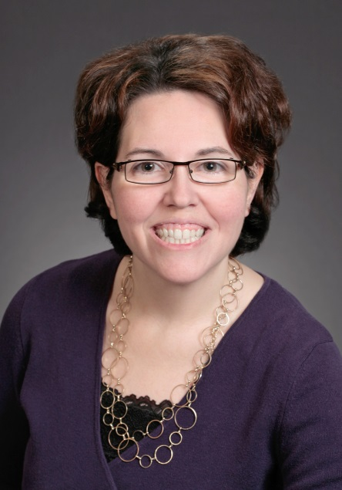
Professional Profile:
Alysa Hartman is currently the Instructional Design & Training Manager for LCS, a leader in the senior lifestyle field. Since joining the company in 2006, she has been responsible for developing and maintaining organization-wide curricula, including live and online solutions, to ensure that LCS is achieving its goals regarding talent development. She also provides event planning and facilitation for multiple national conferences per year.

Alysa’s previous experience includes oversight of curriculum, instruction and assessment for a Head Start program in Missouri; work as an Educational Diagnostician for a large K-12 school district; and providing counseling services at the college level. Alysa earned a Bachelor of Science degree in Psychology/Chemistry and a Master of Science degree in Counseling Psychology from Northwest Missouri State University. She is currently pursuing her Ph.D. in Educational Psychology.

Outside of work, Alysa is an avid reader and enjoys traveling with her husband. She also loves to cook and spend time with her nieces and nephew.

Daniel McCraine

Workshop Title: Executive Strategy Planning

Workshop Description: This workshop will prepare Talent Development and HR professionals to facilitate a strategy planning session for executives. Talent Development and HR professionals will learn how to coach executives to develop goals, uncover barriers, determine mitigation strategies, and create an action plan.

Learning Objectives: By the end of this session, attendees will learn activities to successfully coach executives through a strategy planning process, which includes
- Affinity diagramming
- Root cause analysis tools
- Action planning

Professional Profile:
Daniel McCraine is an expert in delivering training programs that deliver immediate results in behavior, change and performance improvement. He is currently a training consultant and nationally recognized, award winning training professional. Daniel has extensive experience as a performance consultant, e-learning designer, instructional designer, and facilitator.

He earned his Master’s degree from Drake University and completed his undergraduate work at Simpson College. Daniel’s motto is “LEARN all you can so you can SERVE all you can!”

View Daniels testimonials at: www.mccraineassociates.com/testimonials/

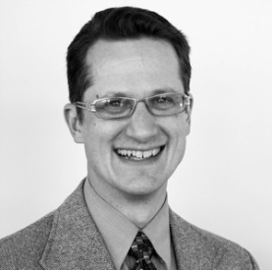

Afternoon Sessions – 1:00PM to 4:00PM

Tabby Hinderaker

Workshop Title: Not Just for Coaches: A Coaching Approach Enhances Learning & Growth

Workshop Description: Regardless of your position, you can use a coaching approach to help people at all levels grow into their full potential. The coachee learns valuable self-correcting behaviors that foster accountability, strengthen interpersonal skills, and accomplish goals. In this highly interactive session, you’ll practice using a coaching approach to inspire others to achieve great things

Learning Objectives: During this session, learners will:
- Identify the characteristics and qualities that support a coaching approach
- Practice applying coaching skills with a partner
- Write their personal definition of what makes a great coach and identify which characteristics they can put into practice right away
Professional Profile
Tabby Hinderaker is founder and life coach at Purposeful Growth, LLC, where her mission is to help people cultivate more presence, make purposeful choices toward their dreams and life goals, and grow the goodness in their life. Tabby served financial services executives and professionals in a variety of Human Resources roles for over 13 years before leaving to start her business. Tabby now helps busy professionals achieve personal excellence by discovering their core values; identifying their dreams, visions, and goals; and building upon their strengths. Tabby facilitates programs for non-profits and small businesses and workshops and retreats for working moms and other busy professionals.
Learn more at www.purposefulgrowthcoach.com
View Tabby’s Podcast: Are You Being Mindful -http://insightonbusiness.podbean.com/e/are-you-mindful/

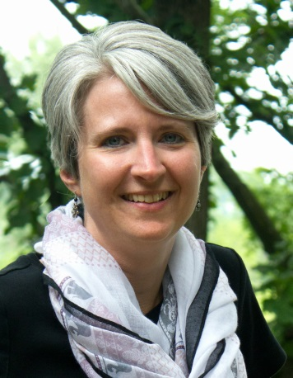

Denise Forney

Workshop Title: Training with Digital Natives in Mind

Workshop Description: In this training session, you will gain vital insights into characteristics of Digital Natives. We will explore how they think, work, play and learn. “Delivering Training with Digital Natives in Mind” will help any training professional stay in step with a generation that’s transforming how business is done and how we can continue to develop their extraordinary talent

Come and experience the training Denise delivered at the 2015 International ATD Conference held in Orlando, FL this past May.

Learning Objectives: During this session, learners will:
- Recognize the unique characteristics of digital natives and the era in which they grew up

- Examine the impact that digital natives are starting to have on the culture of corporate America

- Identify ways that we can connect with digital natives in relation to training methodologies or other human resource initiatives
Professional Profile
Denise Forney is an organizational training and development professional with over eighteen years of progressive management and training expertise. Denise has led training efforts for companies such as Principal Financial Group, Wells Fargo Home Mortgage, and Kemin Industries. She has designed and facilitated courses for both domestic and international audiences, and appreciates the diversity of the customers she has served.
Denise completed her Bachelor of Fine Arts Degree in Public Relations/ Communication from the University of Northern Iowa and holds a Master’s of Science Degree in Adult Education/Training and Development from Drake University. She has served as adjunct instructor for Grand View University in the area of Human Resource Management. Denise is an active member of ATD, presenting at both the 2014 and 2015 International Conference. She also received the Workplace Learning Performance award for “Using Training as a Business Strategy” in 2008 and “Most Innovative Training Solution” in 2010.
Denise brings creativity, passion and energy to her training classroom, engaging her participants in kinesthetic learning activities. She specializes in areas of leadership, mentoring, coaching and feedback, performance management, interviewing skills, presentation skills, diversity in the workplace, and customer service. She values her client relationships, working with individuals to meet their specific training needs, customize solutions, and helping to apply new skills back to the job.
In addition to her training talents in the classroom, Denise is an accomplished guitarist, singer/songwriter. She has released several CD's with her family and enjoys performing music in the community.

